BACHELOR OF COMPUTER SCIENCE
SCHOOL OF COMPUTER SCIENCE
BINA NUSANTARA UNIVERSITY
JAKARTA

ASSESSMENT FORM
Course: COMP6791051 - Program Design Methods
Method of Assessment: Case Study
Semester/Academic Year : Odd /2022-2023

Name of Lecturer : D6672 – Anang Prasetyo
Date : 13 December 2022
Class : LA95, LB95, LC95
Topic : Review Material

Name | Michael Geraldin Wijaya
NIM | 2602238021
Class | LC95

Student Outcomes:
(SO 1) Able to analyze a complex computing problem and to apply principles of computing and other relevant disciplines to identify solutions (SO 2) Able to design, implement, and evaluate a computing-based solution to meet a given set of computing requirements in the context of computer science

Learning Objectives:
(LObj 1.2) Able to apply the principles of computing and other relevant disciplines to identify solutions
(LObj 2.2) Able to implement a computing-based solution to meet a given set of computing requirements in the context of computer science

NO | Learning Outcome | Weight | Key Indicator |  | Proficiency Level |  |  | Score | Weight x Score
 |  |  |  | Excellent | Good | Average | Poor
 |  |  |  | (85 - 100) | (75 - 84) | (65 - 74) | (0 - 64)
1 | LO1: Explain the  requirements of writing a  program or system | 15% | The ability to gather the requirements of a program | The requirement gathered are all correct and complete | The requirement gathered are all correct and almost complete | The requirement gathered are partly correct and almost complete | The requirement gathered are incorrect and incomplete
 |  |  | The ability to explain the requirements for a program | All of the requirements are explained correctly | Some of the requirements are explained correctly | Some of the requirements are explained partly correct | Some of the requirements are explained incorrectly
2 | LO2: Apply pseudocode to solve problem | 30% | The ability to identify the programming problem | At least 90% of the problem is identified correctly | At least 75% of the problem is identified correctly | At least 60% of the problem is identified correctly | Less than 60% of the problem is identified correctly
 |  |  | The ability to apply pseudocode to solve the programing probem | The pseudocode written solves at least 90% of the programming problem | The pseudocode written solves at least 75% of the programming problem | The pseudocode written solves  at least 60% of the programming problem | The pseudocode written solves less than 60% of the programming problem
3 | LO3: Analyze the  requirements of a system | 25% | The ability to collect the requirements for a system | All of the requirement of a system is collected | Some of the requirement of a system is collected | A few of the requirement of a system is collected | The requirement of a system is not collected
 |  |  | The ablity to analyze the collected requirements in order to solve the system | All of the requirements are analyzed correctly | Some of the requirements are analyzed correctly | Some of the requirements analyzed are partly correct | The requirements are analyzed incorrectly
4 | LO4: Solve system design problems using UML | 30% | The ability to design a system using UML Structural Modeling | The ability to design at least 90% correct using Structural Model1 | The ability to design at least 75% correct using Structural Model | The ability to design at least  60% correct using Structural  Model | The ability to design less than  60% correct using Structural  Model
 |  |  | The abIlity to design a system using UML Behavioral Modeling | The ability to design at least 90% correct using behavioral Modeling | The ability to design at least 90% correct using behavioral Modeling | The ability to design at least  90% correct using behavioral  Modeling | The ability to design at least  90% correct using behavioral  Modeling

Remarks:
Case study is a personal work

ASSESSMENT METHOD

Instructions
The library is one of the most important parts of the Binus @Semarang Campus, the library is a place for students to look for study references, discussions, or just read books. As a programmer, you are asked to help the library section to develop a library system with the following criteria:
- The system must include features for borrowing books, returning books, searching for books, managing book stock
- The system can also calculate penalties if students are late in returning books
To build a library system, first make some of the things needed below:
- Make a pseudocode / flowchart (choose one), the features for borrowing books and returning books
- Write down the functional and non-functional requirements for the case above
- Make a use case diagram for the library system
- Make a class diagram of the case above

Final Output
Format :
  - Personal Assignment (Please use application tools for creating any diagrams for this assignment).
  - Format file please export to pdf format.

Due Date : Submit this final assignment in week 13

- PSEUDOCODE
Struct Book(
integer id
string title
string author
string subject
integer stock
)
Struct Loan(
integer id
integer book_id
integer student_id
time_t due_date
real late_fee
)
Struct User(
int id
string name
string email
string address
)
Declare integer num_books
Set num_books = 0
Struct Book as array books
Declare integer num_loans
Set num_loans = 0
Struct Loan as array loans
Declare integer num_users
Set num_students = 0
Struct Student as array students
Module loadData()
Declare InputFile book_file
Open book_file “Books.txt”
If book_file == NULL then if (book_file == NULL)
Display “Error opening Books file (Books file doesn’t exist)” printf("Error opening books file\n");
Return //When the return statement is executed, control is returned to the calling module, and any subsequent statements in the loadData() module are not executed
End if
While not EOF (book_file)
Read book_file books[num_books].id, books[num_books].title, books[num_books].author, books[num_books].subject, books[num_books].stock
Set num_books++
End while
Close book_file
Declare InputFile loan_file
Open loan_file “Loans.txt”
If loan_file == NULL then if (loan_file == NULL)
Display “Error opening Loans file (Loans file doesn’t exist)” printf("Error opening loans file\n");
Return //When the return statement is executed, control is returned to the calling module, and any subsequent statements in the loadData() module are not executed
End if
While not EOF (loan_file)
Read loan_file loans[num_loans].id, loans[num_loans].book_id, loans[num_loans].student_id, loans[num_loans].due_date, loans[num_loans].late_fee
Set num_loans++
End while
Close loan_file
Declare InputFile student_file
Open student_file “Students.txt”
If student_file == NULL then
Display “Error opening Students file (Students file doesn’t exist)”
Return //When the return statement is executed, control is returned to the calling module, and any subsequent statements in the loadData() module are not executed
End if
While not EOF (student_file)
Read student_file students[num_students].id, students[num_students].name, students[num_students].email, students[num_students].address
Set num_students++
End while
Close student_file
End module
Module saveData()
Declare integer i
Declare OutputFile book_file
Open book_file “Books.txt”
For i:=0 to num_books
Write book_file books[i].id, books[i].title, books[i].author, books[i].subject, books[i].stock
End for
Close book_file
Declare OutputFile loan_file
Open loan_file “Loans.txt”
For i:=0 to num_loans
Write loan_file loans[num_loans].id, loans[num_loans].book_id, loans[num_loans].student_id, loans[num_loans].due_date, loans[num_loans].late_fee
End for
Close loan_file
Declare OutputFile student_file
Open student_file “Students.txt”
For i:=0 to num_students
Write student_file students[i].id, students[i].name, students[i].email, students[i].address
End for
Close student_file
End module
Module borrowBook()
Declare integer book_id, student_id, i
Display “Enter the Book ID”
Input book_id
Display “Enter the Student ID: ”
Input student_id
// Check if book is in stock
Declare integer book_index
Set book_index = -1
For i:=0 to num_books for (int i = 0; i < num_books; i++)
If books[i].id == book_id then
Set book_index = i
Break
End if
End for
If book_index == -1 then
Display “Book not found”
Return //When the return statement is executed, control is returned to the calling module, and any subsequent statements in the borrowBook() module are not executed
End if
If books[book_index].stock == 0 then
Display “Book is not in stock”
Return //When the return statement is executed, control is returned to the calling module, and any subsequent statements in the borrowBook() module are not executed
End if
// Check if user exists
Declare integer student_index
Set student_index = -1
For i:=0 to num_students for (int i = 0; i < num_students; i++)
If students[i].id == student_id then
Set student_index = i
Break
End if
End for
If student_index == -1 then
Display “Student not found”
Return //When the return statement is executed, control is returned to the calling module, and any subsequent statements in the borrowBook() module are not executed
End if
// Update book stock
Set books[book_index].stock--
// Create new loan
Struct Loan as loan
Set loan.id = num_loans + 1
Set loan.book_id = book_id
Set loan.student_id = student_id
Set time_t current_time = time(NULL)
Set loan.due_date = current_time + 14 * 24 * 60 * 60
Set loan.late_fee = 0
Set loans[num_loans] = loan
Set num_loans++
Display “Book borrowed succesfully”
End module
Module returnBook()
Declare integer book_id, student_id, i
Display “Enter the Book ID: ”
Input book_id
Display “Enter the Student ID: ”
Input student_id
// Find loan
Declare integer loan_index
Set loan_index = -1
For i:=0 to num_loans for (int i = 0; i < num_loans; i++) {
If loans[i].book_id == book_id AND loans[i].student_id == student_id then
Set loan_index = i
Break
End if
End for
If loan_index == -1 then if (loan_index == -1)
Display “Loan not found”
Return //When the return statement is executed, control is returned to the calling module, and any subsequent statements in the returnBook() module are not executed
End if
// Find book
Declare integer book_index
Set book_index = -1
For i:= 0 to num_books
If books[i].id == book_id then
Set book_index = i
Break
End if
End for
If book_index == -1 then
Display “Book not found”
Return //When the return statement is executed, control is returned to the calling module, and any subsequent statements in the returnBook() module are not executed
End if
// Update book stock
Set books[book_index].stock++
// Check if the book was returned late
Set time_t current_time = time(NULL)
If current_time > loans[loan_index].due_date then
Set loans[loan_index].late_fee = (current_time - loans[loan_index].due_date) / (24 * 60 * 60) * 100; // Late fee is $1 per day
Display “Book was returned late. The late fee is $loans[loan_index].late_fee/100”
Else
Display “Book returned succesfully”
End if
// Remove loan
For i:= loan_index to num_loans for (int i = loan_index; i < num_loans - 1; i++) {
Set loans[i] = loans[i+1]
End for
Set num_loans--;
End module
Module main()
Call loadData()
Declare integer choice
While choice not 5
Display “BINUS @SEMARANG LIBRARY”
Display “1. Borrow Book”
Display “2. Return Book”
Display “3. Search for Book”
Display “4. Manage Book Stock”
Display “5. Exit”
Display “Enter Choice: ”
Input choice
Select choice
Case 1:
Call borrowBook()
Break
Case 2:
Call returnBook()
Break
Case 3: //Here I do not make pseudocode for cases 3 and 4 because the instructions given are only cases other than 3 and 4 ( 1 and 2)
Case 4: //Here I do not make pseudocode for cases 3 and 4 because the instructions given are only cases other than 3 and 4 ( 1 and 2)
Case 5:
Call saveData()
Display “Exit…”
Break
Default:
Display “Invalid choice, please input the valid seletion”
Break
End select
End while
End module
- Functional and Nonfunctional Requirements
Functional Requirements

Borrow Books
  - Ability to borrow books by logging in with a student ID and selecting a book from the available stock.

Return Books
  - Ability to return books by logging in with a student ID and selecting a book from the list of borrowed books.
  - Ability to calculate penalties for late book returns by comparing the return date with the due date

Search Books

Ability to search for books by title, author, or subject.

Manage Books
  - Ability to manage book stock by adding new books, editing book information, and deleting books.

Nonfunctional Requirements
- Usability Requirements
  - The system should have a user-friendly interface with intuitive navigation and simple search capabilities.
- Maintenance Requirements
  - The system should be easy to maintain and update as needed.
- Security Requirements
  - The system should ensure the security and privacy of student and book information.
- Scalability Requirements
  - The system should be able to accommodate an increase in the number of books and students in the future.
- Integration Requirements
  - The system should be able to integrate with existing library systems and other university systems, such as student information systems.
- Performance Requirements
The system must efficiently complete tasks without causing delays for the user.
- Compatibility Requirements
The system should be able to function on a variety of devices and operating systems.

- Use Case Diagram
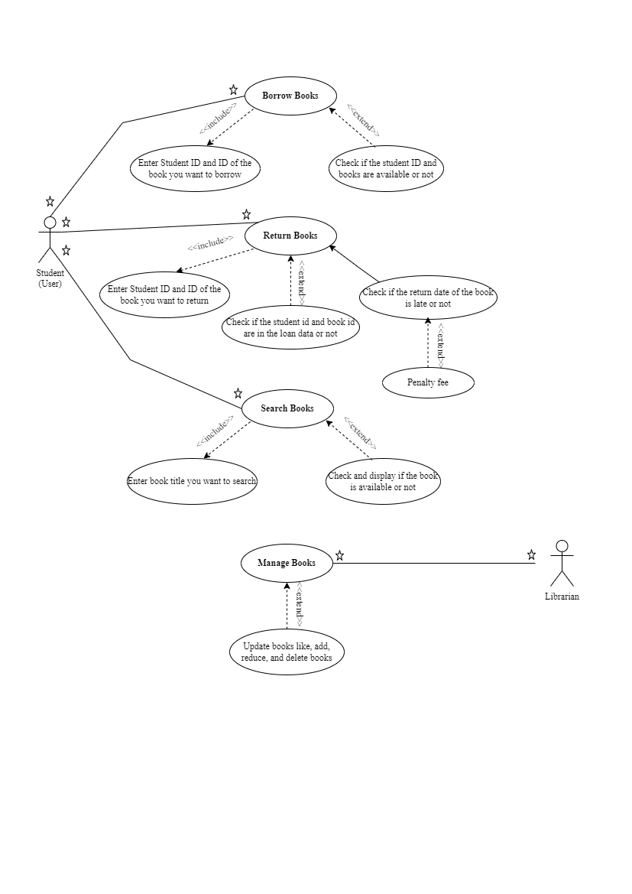

- Class Diagram
